**Design & Technology**

**

**Polymer processes**

**Materials required for questions**

* Pencil
* Rubber
* Calculator

**Instructions**

* Use black ink or ball-point pen
* Try answer all questions
* Use the space provided to answer questions
* Calculators can be used if necessary
* For the multiple choice questions, circle your answer

**Advice**

* Marks for each question are in brackets
* Read each question fully
* Try to answer every question
* Don’t spend too much time on one question

**Good luck!**

**Q1.** Which process is most suitable for producing thin, uniform plastic sheets like PVC for flooring?

**A** Vacuum forming

**B** Calendaring

**C** Line bending

**Q2.** What method is ideal for manufacturing hollow, seamless products such as plastic fuel tanks?

**A** Blow moulding

**B** Rotational moulding

**C** Compression moulding

**Q3.** Which technique is best for high-volume production of small, intricate plastic parts like LEGO bricks?

**A** Injection moulding

**B** Extrusion

**C** Thermoforming

**Q4.** What process uses heated sheets of plastic stretched over a mould to create products like food packaging trays?

**A** Vacuum forming

**B** Laminating (layup)

**C** Line bending

**Q5.** Analyse and evaluate the suitability of rotational moulding for the manufacture of the child’s art easel shown below **(6 marks)**

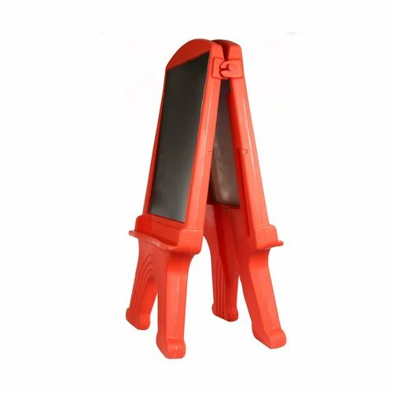

**Q6.** A polymer extrusion process has been used to produce the rigid polyvinyl chloride (PVC) cable trunking shown below. Describe the main stages of the polymer extrusion process **(6 marks)**

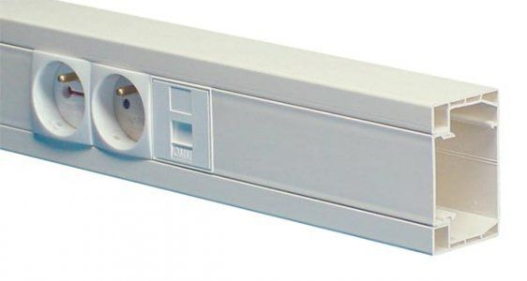

**Q7.** Explain why injection moulding is not a suitable manufacturing method for large products **(6 marks)**

**Q8.** Describe the stages required to produce a vacuum formed polymer product **(6 marks)**

**Answers**

**Q1**. B

**Q2**. B

**Q3**. A

**Q4**. A

**Q5**.

* Rotational moulding would be a suitable process for producing a hollow component of the size and scale of the child’s art easel.
* The complexity of the design is limited, with large radiused edges and minimal intricate detail making rotational moulding an appropriate manufacturing method.
* Rotational moulding allows for a thicker wall thickness than other polymer redistribution processes meaning that the easel will be rigid and stable when in use.
* Rotational moulding produces a lightweight hollow structure which allows the easel to be easily carried or moved and prevent an injury should the easel fall over.
* Rotational moulding produces a one-piece structure that allows the easel to be manufactured out of a minimal number of parts, reducing assembly time.
* Rotational moulding is suitable for large batch production which reflects the size of the consumer market for the child’s art easel. Rotational moulding allows for pigmentation to be added to the component at the point of manufacture

**Q6**.

* Thermoplastic polymers are loaded in to a hopper.
* An Archimedean screw moves the polymer through a heated chamber softening the polymer.
* The molten polymer is forced through a steel die.
* The die would have the appropriate pattern needed for the cable trunking.
* The extrusion is then supported by rollers as it leaves the die.
* The extrusion is then rapidly cooled by water or air.
* The extrusion may also be pulled through the die to keep the extrusion under tension and therefore stop any deformation of the profile.
* The extrusion is then cut to the desired length.

**Q7.**

* The weight and scale of the mould can make large tooling prohibitive to handle when being manufactured.
* The physical size of the injection moulding machine limits the maximum size of the mould available.
* The costs associated with the production of a large injection mould would be hugely prohibitive, including the material of the mould, the injection moulding machine, the industrial space to locate the machine itself.
* The polymer cooling too quickly means the cavities of the mould may not fill completely.
* A large mould with thick walls increases problems associated with shrinkage.
* Injection moulding may prove challenging to design a successful large moulding with a thin wall thickness.

**Q8.**

Mould production

* An accurate mould resembling the desired product is manufactured.
* The mould may feature elements such as tapered sides, radiused edges, vacuum holes etc to aid a successful polymer moulding.
* The completed mould is placed on the bed of the machine known as the ‘platen’.

Mounting the polymer sheet in the machine

* The thermoplastic polymer sheet is clamped into the machine above the mould creating an airtight seal.

Heating the polymer sheet

* The polymer is then heated via a radiant heater.

Moulding the product

* When the polymer is heated and has softened, the heat is removed.
* The polymer sheet may be blown a little before raising the platen and mould into the softened sheet.
* The vacuum pump is switched on and the air removed forcing the sheet to take the shape of the mould.

Removal of the mould

* Once cooled, the mould is removed by lowering the platen.
* Air can be blown in between the mould and moulding to aid its release.
* The moulding is unclamped and removed from the vacuum forming machine.

Trimming and finishing of the polymer product

* Waste material is trimmed from the mould and can then be recycled.
* Any apertures can be cut out and any decals or printed details can be added to the moulded product.